Write a query to display department_name,no_of_employees departments having 20 or more than 20 emplyees

Query:

select department_name,count(salary) as no_of_employees

from employees e,departments d

where d.department_id=e.department_id

group by department_name

having count (*) >=20;

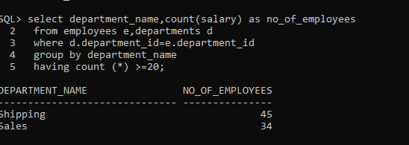

Write a query to display employee_id, first_name, last_name, salary from employees who’s salary greater than average salary of own department.

Query:

select employee_id,first_name,last_name,salary

from employees e

where salary>(select avg(salary) from employees e1

where e.department_id=e1.department_id

group by e.department_id);

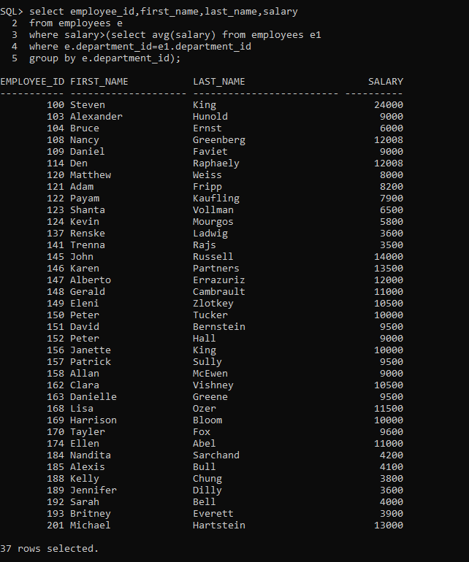

Write a query to display employee_id,first_name, last_name,full_name,salary,new_salary,(salary*10), difference(new_salary-salary)

Query:

select employee_id,first_name,last_name,

(first_name)||' '||(last_name) as full_name,salary ,

(salary*10) as new_salary,((salary*10)-salary) as difference

from employees;

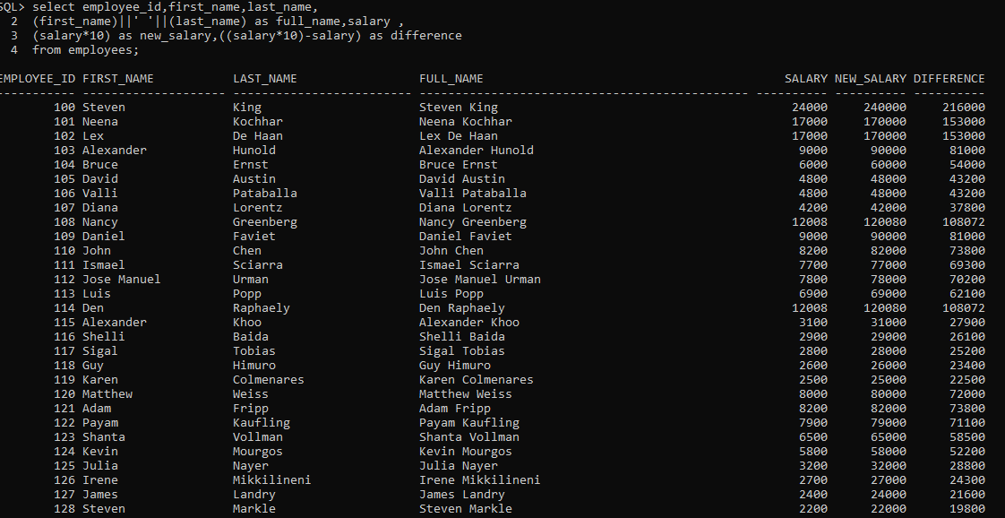

Display top 3 highest salary employees(employee_id,first_name,salary)

Query:

select employee_id,first_name,salary

from employees

WHERE ROWNUM<=3

order by salary desc;

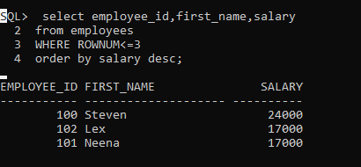

Display employee_id,first_name,last_name manager_id is null

Query:

select employee_id,first_name,last_name,manager_id

from employees

where manager_id is null;

